# Paper

Projecting the role of sediment management and sea level rise in driving habitat suitability for salt marsh obligate birds

# Keywords

# Abstract

# Introduction

# Method

1. Modeling of LFRR and BSS

To develop a model for vegetation based on inundation and elevation we used elevation from a 2012 survey and water level from 2012 in NOAA. We subtracted the water level from the elevation, hourly, over the entire year for a stack of 8784 raster’s showing the depth of the water over each pixel at every hour, or the height above the water level at each pixel at every hour. Calculated a series of metrics to describe the annual inundation pattern for the winter (jan-Mar, Nov-Dec) and summer months (April-Sept). The inundation metrics were highly correlated with each other.

|  |  |
| --- | --- |
| avg_height_above_water_level | Mean of height above water (when pixel values are >0) |
| avg_depth_below_water_level | Mean of depth below water (when pixel values are <0) |
| avg_height | Average of all values |
| max_height_above_water_level | Max of height above water (when pixel values are >0) |
| max_depth_below_water_level | Max of depth above water (when pixel values are <0) |
| pct_inundated | The number of hours when the land is submerged divided by all the hours in the year (8784) |

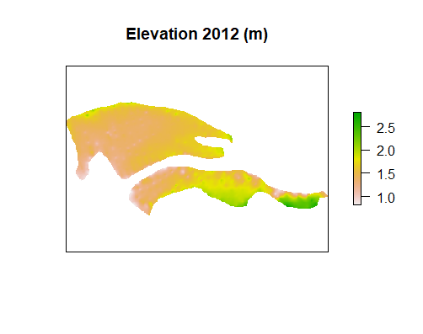

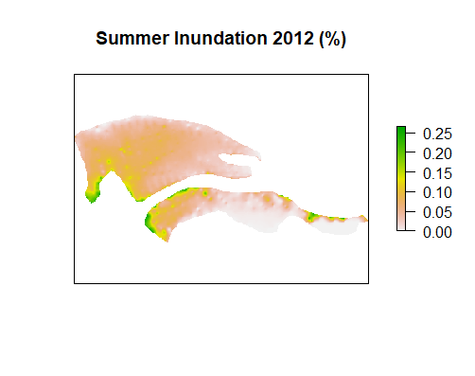

A veg survey was also completed in 2012 at 240 points in UNB. At each point, we extracted the inundation metrics and the elevation. We modeled SPSP_MAX (the maximum height of a spartina stem recorded in the quadrat during the 2012 survey) using a zero inflated negative binomial model – the count data was modeled with annual inundation during the summer month and annual inundation during the summer month squared, and the binomial was modeled with annual inundation during the summer month.

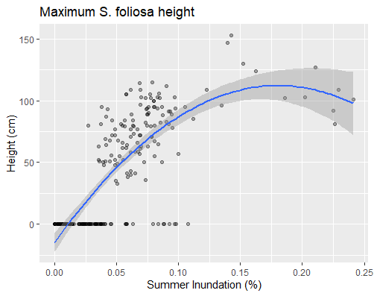

Figure 1: smoothed like: y = x+x2

Call:

zeroinfl(formula = SPSP_MAX ~ summ_inu_pct + summ_inu_pct_sq | summ_inu_pct, data = veg, dist = "negbin", EM = TRUE)

Pearson residuals:

Min 1Q Median 3Q Max

-3.8632 -0.4407 -0.1948 0.5115 3.0926

Count model coefficients (negbin with log link):

Estimate Std. Error z value Pr(>|z|)

(Intercept) 3.6953 0.1134 32.579 < 2e-16 ***

summ_inu_pct 11.9414 2.2394 5.332 9.69e-08 ***

summ_inu_pct_sq -34.1737 8.7022 -3.927 8.60e-05 ***

Log(theta) 3.0312 0.1631 18.584 < 2e-16 ***

Zero-inflation model coefficients (binomial with logit link):

Estimate Std. Error z value Pr(>|z|)

(Intercept) 3.5166 0.4795 7.334 2.23e-13 ***

summ_inu_pct -77.3171 9.6483 -8.014 1.11e-15 ***

---

Signif. codes: 0 '***' 0.001 '**' 0.01 '*' 0.05 '.' 0.1 ' ' 1

Theta = 20.7217

Number of iterations in BFGS optimization: 1

Log-likelihood: -629 on 6 Df

We then used this model to predict the maximum height of spartina in the marsh for 2012 (validation set), and years 2011-2018 (for prediction). For the years 2011 -2018, we similarly subtracted the hourly water level from the elevation raster to get hourly inundation, from which we calculated the series of inundatin metrics. Note the levels differed each year slightly with 2015 having the highest water levels.

* + - 1. 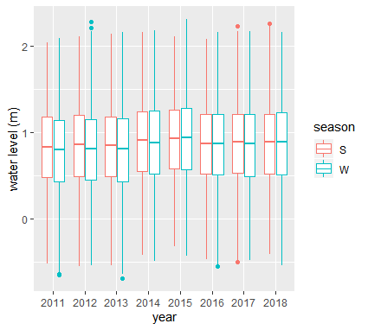

Table : mean and sd of hourly water level for different years.

|  |  |  |
| --- | --- | --- |
| year | mean (m) | sd (m) |
| 2011 | 0.7977517 | 0.5098197 |
| 2012 | 0.8174518 | 0.5041937 |
| 2013 | 0.8124893 | 0.4996088 |
| 2014 | 0.879911 | 0.4984126 |
| 2015 | 0.9189163 | 0.4985738 |
| 2016 | 0.8514621 | 0.4929819 |
| 2017 | 0.8526349 | 0.4947864 |
| 2018 | 0.8640081 | 0.5047017 |

To predict with a zero inflated model, we used the model to predict a “response”, or a numerical value for the spartina height, and a “zero” or a probability of the max height being zero (ie no spartina present). If the probability of a zero was greater than 0.5, we assigned that value to be 0, and if it was less than 0.5, we assigned it to be 1. Then we multiplied the “response’ and the “zero” together such that the final value was 0 is the prob of 0 was >0.5 and it was a numberical height if the prob of zero was <0.5.

When using this model for prediction on the training data (2012), there are 14 observations that show S.foliosa height that should have been a zero, and there were 15 predictins for a height that should have been zero.

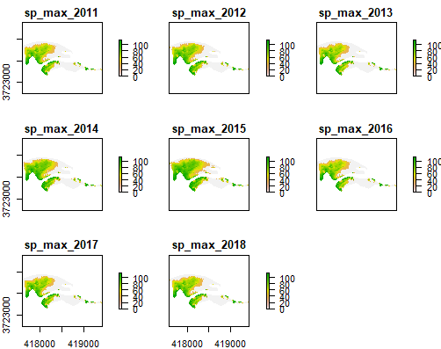

Figure 2: plots showing the predicted max height of spartina each year based on summer inundation model. White space means the model predicted a greater than 50% chance of a zero ie no spartina. Using karens elevation

Table 2: summary stats for the max height of spartina in each year in cm

|  |  |  |  |
| --- | --- | --- | --- |
| year | mean | sd | median |
| sp_max_2011 | 37.08 | 38.64963 | 36.99 |
| sp_max_2012 | 39.80 | 39.51643 | 40.07 |
| sp_max_2013 | 34.89 | 38.29719 | 0.00 |
| sp_max_2014 | 43.81 | 40.84842 | 48.03 |
| sp_max_2015 | 50.13 | 40.41019 | 57.78 |
| sp_max_2016 | 36.31 | 38.76256 | 34.48 |
| sp_max_2017 | 35.25 | 39.34844 | 0.00 |
| sp_max_2018 | 36.97 | 39.07116 | 34.84 |

Using the spartina predictions for each year, we modeled light footed Ridgway’s rail habitat suitability. The modeled was trained with spatially explicit LFRR survey data. We split the marsh up into acre parcels. Each parcel was assigned a number, 0-8, depending on the number of years that a rail was observed in that parcel (Figure 3). For each parcel, we then extracted a series of spartina metrics (ex median, 75th percentile). The number of years of rail occupany was modeled using the modeled spartina metrics.

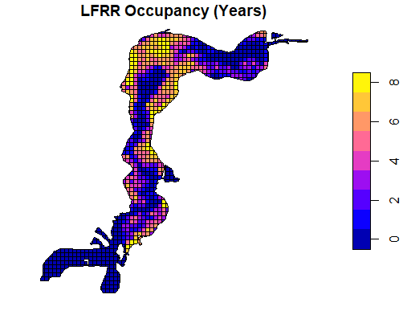

Figure 3: the number of years, 2011 – 2018 that the acre was occupied by a LFRR based on dicks surveys

|  |  |  |  |  |  |  |  |  |
| --- | --- | --- | --- | --- | --- | --- | --- | --- |
| term | estimate | std.error | p.value | odds_ratio | lwr_lim | upr_lim | OR_lwr_lim | OR_upr_lim |
| SPSP_MAX_grt60 | 0.869451 | 0.079694 | 1.03E-27 | 2.385602 | 0.713251 | 1.025652 | 2.040614 | 2.788913 |
| SPSP_MAX_95 | 0.009037 | 0.000769 | 6.91E-32 | 1.009078 | 0.00753 | 0.010544 | 1.007558 | 1.0106 |

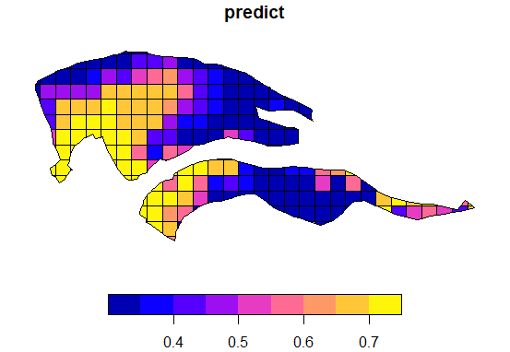

Figure 4: predicted number of years of rail occupancy for year 2011 using spartina metrics.

Projection for future habitat suitability based on delft3D marsh surface models

Sediment dredging, augmentation, and SLR

The spartina model was trained using elevation and water elvel data in NAVD88, and it was used to predict in the future on data in MSL datum. However, because it was normalized when converted to inundation metrics, the model is transferable.

We first projected inundation metrics using SLR for water level, and marsh surface elevation based on business as usual dredging to determine what habitat suitability will look like under business as usual. SLR scenarios: we chose 0.54864m and 1.09728m (Griggs et al., 2017) because those bound the 67% likely range of sea level rise by 2100 under RCP8.5. We added those values to the water level time series from 2015 (an el nino year) and 2011 a normal year. The surface elevation rasters were for the entire marsh and were produced from Delft3D modeling. For each combination (total of 8 combinations) we subtracted the hourly water level from the elevation and calucated the same metrics calcuated in the baseline years. Then, for each combination, we used the maximum spartina model to predict the maximum height of spartina in the marsh.

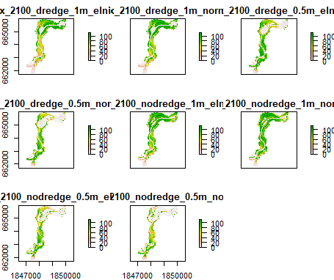

Figure 5: rasters showing the max height of spartina predicted for future year 2100. Different plots are for different dredging, SLR, and el nino conditions.

|  |  |  |  |  |  |  |  |  |
| --- | --- | --- | --- | --- | --- | --- | --- | --- |
|  | Dredging | | | | No Dredging | | | |
|  | 1m | | 0.5 | | 1m | | 0.5 | |
| quantiles | El nino | normal | El nino | normal | El nino | normal | El nino | normal |
| 0% | 0 | 0 | 0 | 0 | 0 | 0 | 0 | 0 |
| 25% | 4 | 4 | 3 | 0 | 15 | 15 | 0 | 0 |
| 50% | 55 | 70 | 47 | 22 | 79 | 84 | 11 | 3 |
| 75% | 97 | 104 | 93 | 82 | 104 | 107 | 79 | 64 |
| 100% | 114 | 114 | 114 | 114 | 114 | 114 | 114 | 114 |

1. Projection for future population accounting for greater storms ..

# Results

1. Spatial map of habitat occupancy probability under SLR and no sediment mgmt. change
2. Spatial map of habitat occupancy probability under SLR and no dredge
3. Spatial map of habitat ccupnayc probiliby under SLR and augmentation
4. Line graph of breeding populatin - does habitat suitability matter more, or do the streamflows??? This one I am unsure of